Fishes of the Mid-West ID Activity
Directions: Look at the picture of the fish and answer the questions and identify the species of fish.
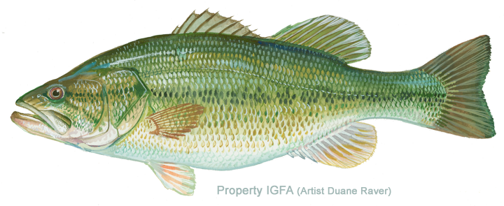
Common Name_____________________________________________
Number of dorsal fins________
Identification Observations:
Fishing tips:
Adult size:________________
Food:____________________________________________________________
Spawning:
Range and Habitat:

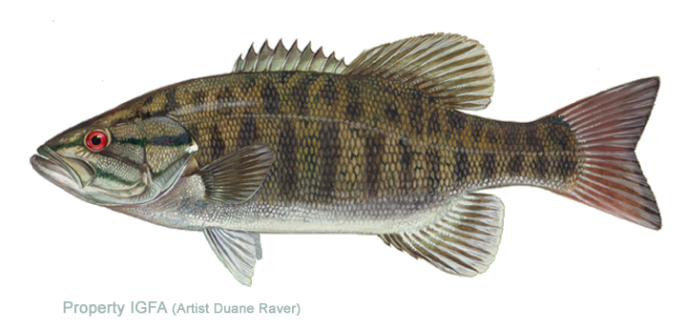
Common Name_____________________________________________
Number of dorsal fins________
Identification Observations:
Fishing tips:
Adult size:________________
Food:____________________________________________________________
Spawning:
Range and Habitat:

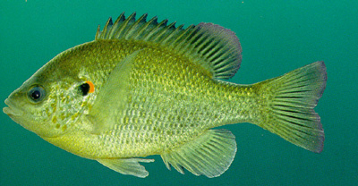
Common Name_____________________________________________
Number of dorsal fins________
Identification Observations:
Fishing tips:
Adult size:________________
Food:____________________________________________________________
Spawning:
Range and Habitat:

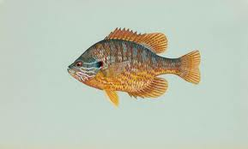
Common Name_____________________________________________
Number of dorsal fins________
Identification Observations:
Fishing tips:
Adult size:________________
Food:____________________________________________________________
Spawning:
Range and Habitat:
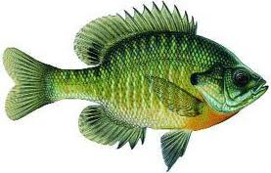

Common Name_____________________________________________
Number of dorsal fins________
Identification Observations:
Fishing tips:
Adult size:________________
Food:____________________________________________________________
Spawning:
Range and Habitat
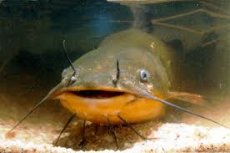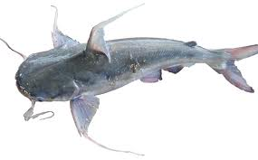

Common Name_____________________________________________
Number of dorsal fins________
Identification Observations:
Fishing tips:
Adult size:________________
Food:____________________________________________________________
Spawning:
Range and Habitat:
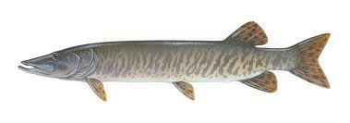
Common Name_____________________________________________
Number of dorsal fins________
Identification Observations:
Fishing tips:
Adult size:________________
Food:____________________________________________________________
Spawning:
Range and Habitat:
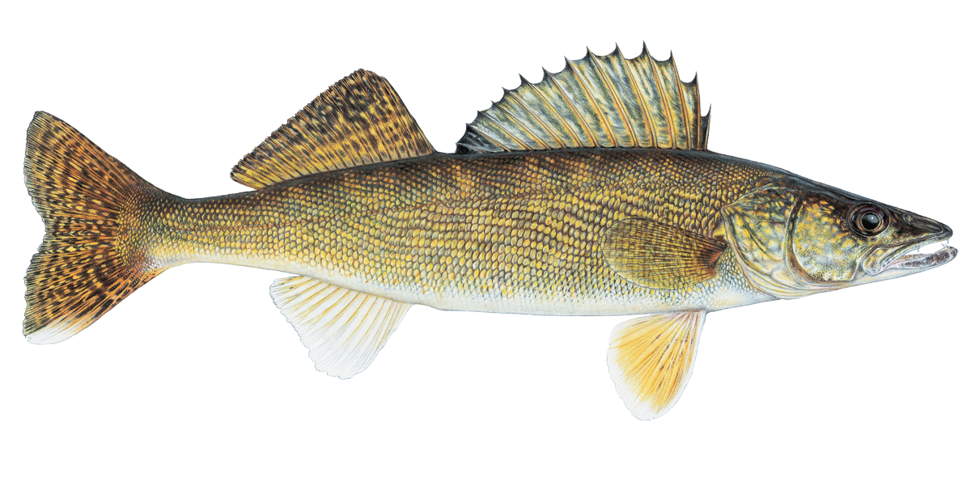
Common Name_____________________________________________
Number of dorsal fins________
Identification Observations:
Fishing tips:
Adult size:________________
Food:____________________________________________________________
Spawning:
Range and Habitat:
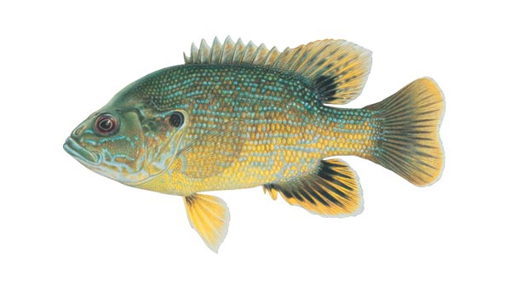

Common Name_____________________________________________
Number of dorsal fins________
Identification Observations:
Fishing tips:
Adult size:________________
Food:____________________________________________________________
Spawning:
Range and Habitat:
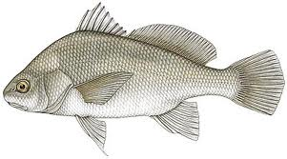
Common Name_____________________________________________
Number of dorsal fins________
Identification Observations:
Fishing tips:
Adult size:________________
Food:____________________________________________________________
Spawning:
Range and Habitat:
Common Name_____________________________________________
Number of dorsal fins________
Identification Observations:
Fishing tips:
Adult size:________________
Food:____________________________________________________________
Spawning:
Range and Habitat:

